**Visual programming Practical Assignment 2**

Design a windows application that reads a json file and display any question at random. The user should select the correct option to answer the question from the provided options.

If the selected option is correct, display the correct feedback from the json file in a message box. Also, if the answer is wrong, display the wrong feedback from the json file.

The message box OK button should repeat the process. If the user fails to answer correctly for 3 consecutive times, generate a failure message and terminate the program!

Your designs should be as follows:

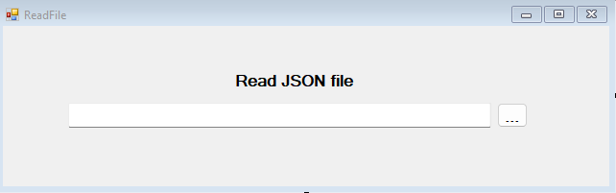

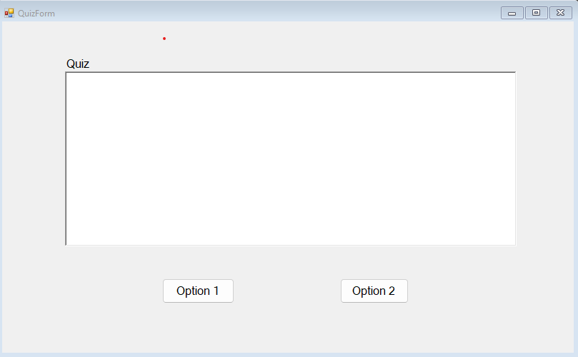

**Json file.**

Save this json as quiz.json

{

       "category": "Secure Your Secrets",

        "questions": [

          {

"question": "Hey [insert your name here], I am trying to create a secure password for one of my online accounts. Can I just resuse one of my passwords?",

            "options": [ "Yes", "No" ],

            "answer": "No",

            "correct_feadback": "Correct! It's advisable to have seperate password for each of your accounts. If one is breach, others will remain secured.",

            "wrong_feadback": "it is not safe to use the same password for all of your online accounts because if one of your account is breached, all of your accounts will be exposed."

          },

          {

            "question": "[insert your name here], How are you? Help me out! Is it secure to have a password like: 'IloveBuddy'?",

            "options": [ "Yes", "No" ],

            "answer": "No",

            "correct_feadback": "Correct! Using commonly use personal information like a pet's name, are easy to crack, and can be guessed by someone who knows you.",

            "wrong_feadback": "Never use commonly use personal information like a pet's name or favorite toy etc because it can be easly guessed by someone who knows you."

          },

          {

            "question": "How are you [insert your name here]? Please give me the password for your desktop machine.",

            "options": [ "OK", "No" ],

            "answer": "OK",

            "correct_feadback": "It's ok to share password with your parents or guardian.",

            "wrong_feadback": "It's ok to share password with your parents or guardian."

          },

          {

            "question": "Hey pal, I keep on forgeting my password. Should I write it down.",

            "options": [ "Yes", "No" ],

            "answer": "No",

            "correct_feadback": "Make your passwords memorable so you don't need to write them down, which would be risky",

            "wrong_feadback": "It's risky to write passwords down but if you do so never write them where someone can find them."

          },

          {

            "question": "Hey [insert your name here], Send your password and I will upload the assigment for you.",

            "options": [ "Yes", "No" ],

            "answer": "No",

            "correct_feadback": "Correct! Passwords should be kept private.",

            "wrong_feadback": "Don't share your passwords with anyone but a parent or other adult you totally trust."

          }

        ]

}